CS 255 System Design Document Template

UML Diagrams

UML Use Case Diagram
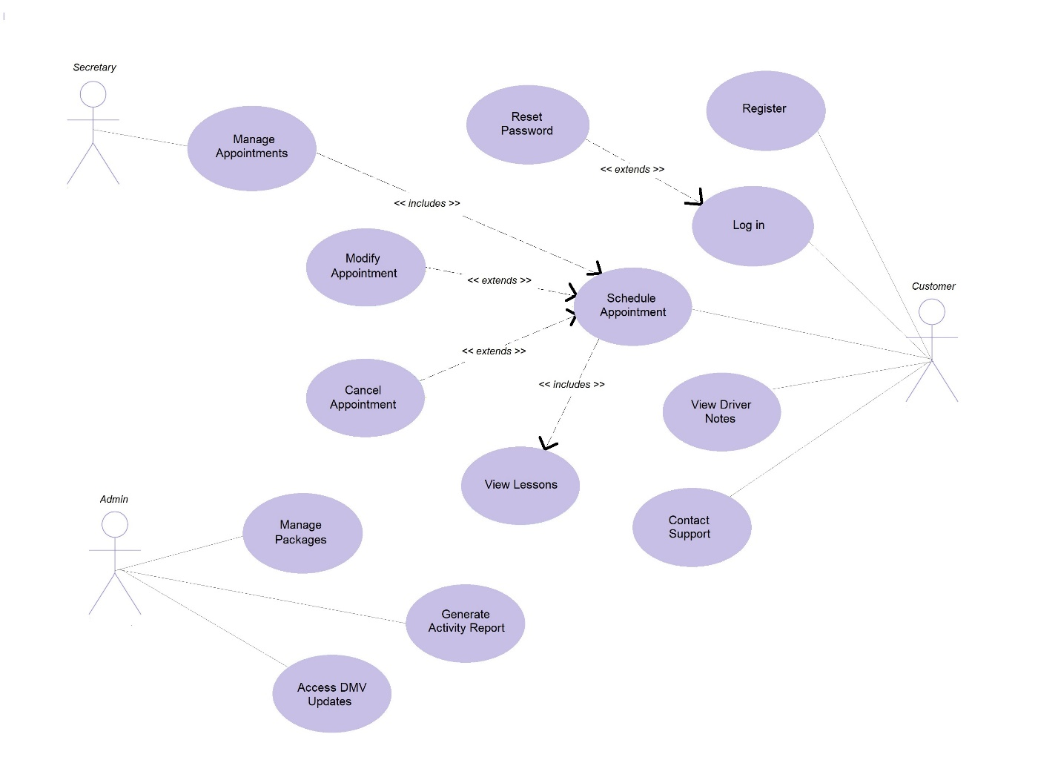

UML Activity Diagrams
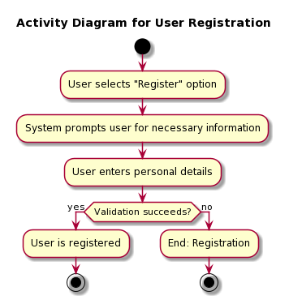

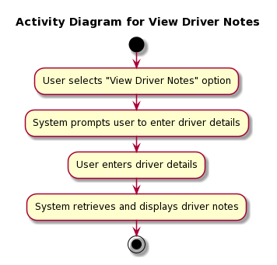

UML Sequence Diagram
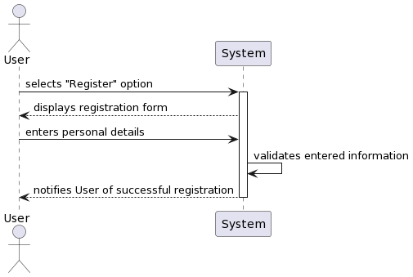

UML Class Diagram
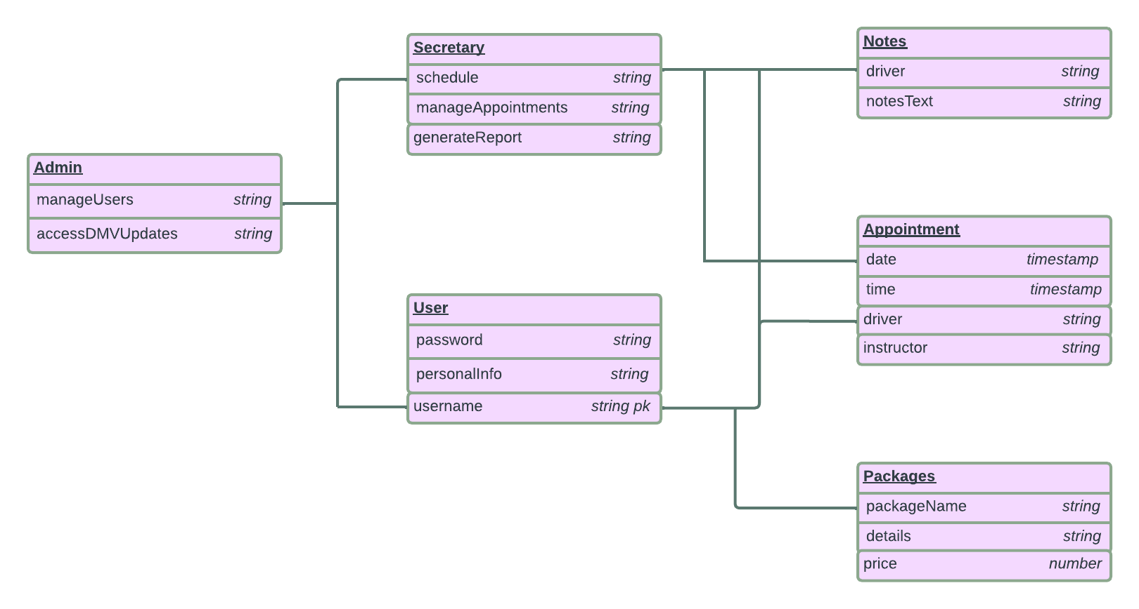

Technical Requirements
Here are the technical requirements for my system:

Hardware needs: my system will require strong hardware, like servers, to run the application and store data. These servers should be powerful enough to handle more users, instructors, and lessons as my system grows. We'll also need backup servers to ensure the system stays up even if something fails.

Software basics: for my system to work well we'll need some essential software. This includes a good web server to run the application, a database system to store information, and a reliable operating system to manage the servers. All of this software should be able to grow with my system and adapt to future changes.

Keeping things safe: security is a TOP priority. My system must make sure that customer data and financial info are protected. We will use encryption to keep sensitive data safe during transfer and storage. We will also have rules in place to control who can access what. Plus, we' will regularly check for and fix any security issues.

Growing smoothly: as my system gets bigger, it needs to expand smoothly. We will use load balancers to spread out the workload and make sure the system can handle more users. We might also use cloud based solutions and a database that can handle lots of data.

Backing up data: we'll regularly make copies of our data and have a plan in case something goes wrong. This way, we can recover lost data if there's an unexpected problem.

Helping users: to support our customers, we'll have tools in place for answering their questions and helping them out. We might use a special system for this, or customer management software to keep everything organized.
Following the rules: since my system deals with driving lessons, it needs to follow the rules set by the DMV. We'll make sure we have the right tools and processes to make sure we're following all the regulations.
These are the technical requirements that my system needs to operate smoothly and securely, while also being ready for future growth.

